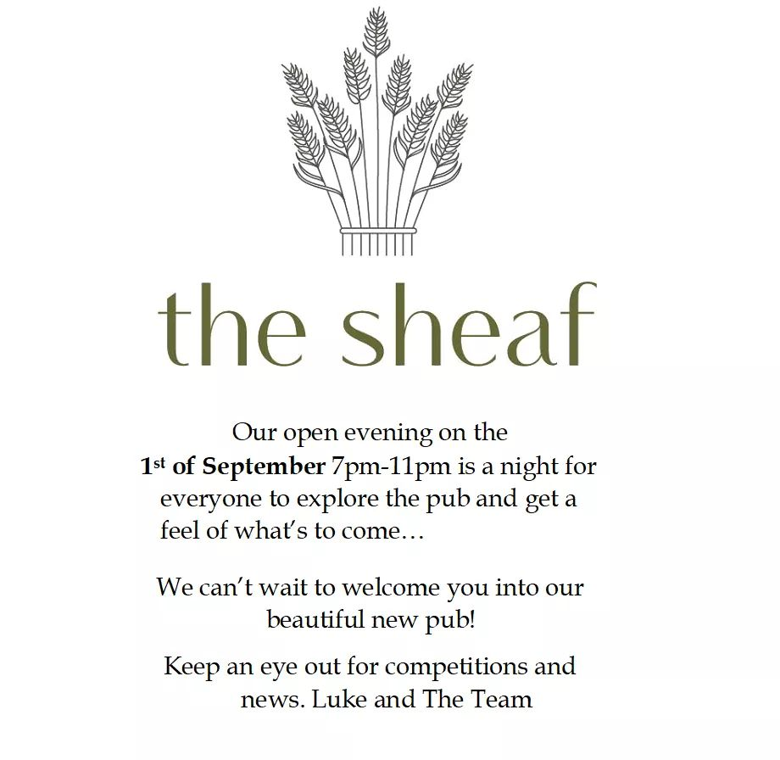

Menu Pre-order Form

Please return this form to info@thesheafinn.co.uk 3 days before your booking.

*Any questions, please don’t hesitate to get in touch.*

|  |  |  |  |  |
| --- | --- | --- | --- | --- |
| Booking name: |  | | | |
| Contact details: |  | | | |
| Date of party: |  | | | |
| Name | Starter | Main | Dessert | Allergies? |
|  |  |  |  |  |
|  |  |  |  |  |
|  |  |  |  |  |
|  |  |  |  |  |
|  |  |  |  |  |
|  |  |  |  |  |
|  |  |  |  |  |
|  |  |  |  |  |
|  |  |  |  |  |
|  |  |  |  |  |
|  |  |  |  |  |
|  |  |  |  |  |
|  |  |  |  |  |
|  |  |  |  |  |
|  |  |  |  |  |
|  |  |  |  |  |
|  |  |  |  |  |
|  |  |  |  |  |
|  |  |  |  |  |
|  |  |  |  |  |